<https://github.com/cztomczak/phpdesktop/releases/tag/chrome-v130.1>

Download the **[phpdesktop-chrome-130.1-php-8.3.zip](https://github.com/cztomczak/phpdesktop/releases/download/chrome-v130.1/phpdesktop-chrome-130.1-php-8.3.zip)**

<https://mariadb.org/download/?t=mariadb&p=mariadb&r=12.0.2&os=windows&cpu=x86_64&pkg=zip&mirror=ossplanet>

Download

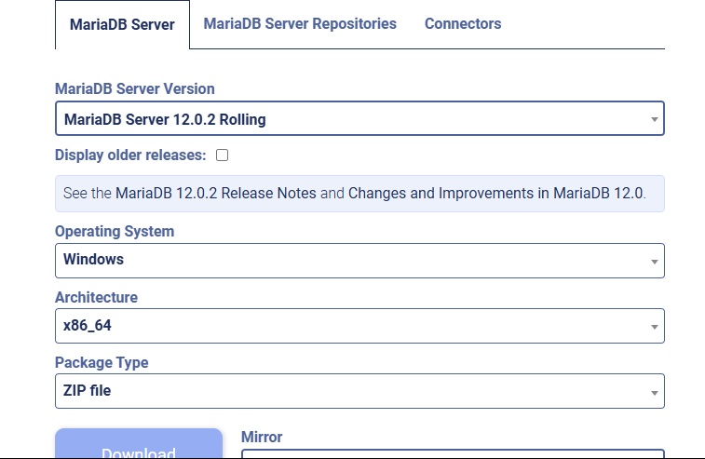

cd php_desktop\mysql\bin

mysqld --initialize-insecure --basedir=.. --datadir=..\data

Extract **[phpdesktop-chrome-130.1-php-8.3.zip](https://github.com/cztomczak/phpdesktop/releases/download/chrome-v130.1/phpdesktop-chrome-130.1-php-8.3.zip)** and name it “php_desktop”

1. Prepare your project and name it laravel
2. Open “php_desktop” click www
3. Paste your laravel in www

4 change your .env

DB_CONNECTION=mysql

DB_HOST=127.0.0.1

DB_PORT=3307

DB_DATABASE=laravel_app

DB_USERNAME=root

DB_PASSWORD=

Open php_desktop/settings.json and paste this



Open php_desktop and create StartLaravel